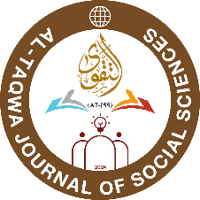

atjss.at.edu.af

COPYRIGHT DECLARATION



**AL-TAQWA JOURNAL OF SOCIAL SCIENCES (AT-JSS)**

**Title of the Article:**



**Authors:**



**Corresponding Email:**



**Contact Number:**

I/We thus grant the publisher, AL-TAQWA JOURNAL OF SOCIAL SCIENCES, copyright to the above-mentioned article. I/We acknowledge that ATJSS will publish, reproduce, distribute, and transmit the Work on my/our behalf. I/We guarantee that the work is free of illegal assertions, has never been published previously in its current or substantially comparable form, and is not currently being considered for publication. I/We guarantee that "proof of consent" has been secured for research involving certain individuals and organizations. After receiving the final draft of the work, each author accepts responsibility for its content and consents to its submission. I/We claim the moral right to be recognized as the work's author or authors.

|  |  |  |  |  |
| --- | --- | --- | --- | --- |
| **S.No** | **Name of Author’s** | **Author’s Affiliation** | **Date** | **Signature** |
| **1** |  |  |  |  |
| **2** |  |  |  |  |
| **3** |  |  |  |  |
| **4** |  |  |  |  |
| **5** |  |  |  |  |

**Note:** In case if all authors are not available then only one author’s signature is sufficient.